**Running iModules–Converge Report Merge Process**

1. **Install Ruby on Windows**

Visit <http://rubyinstaller.org/>

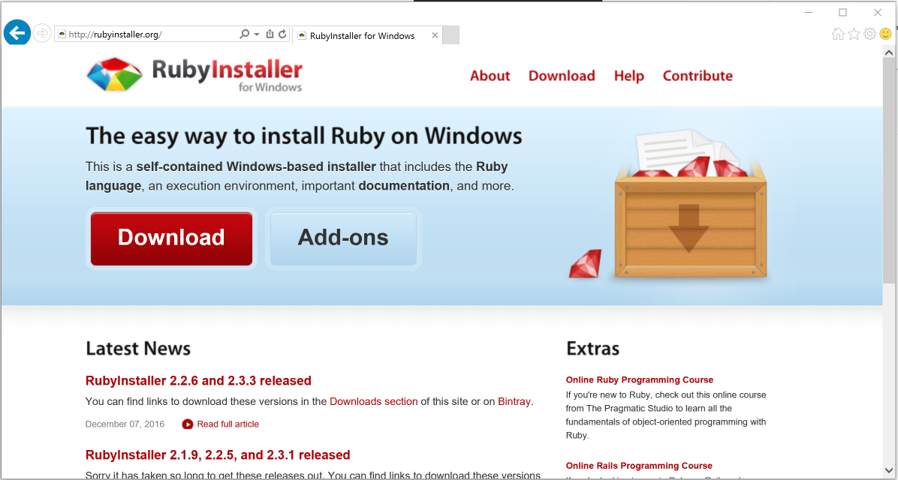

Click “Download”.

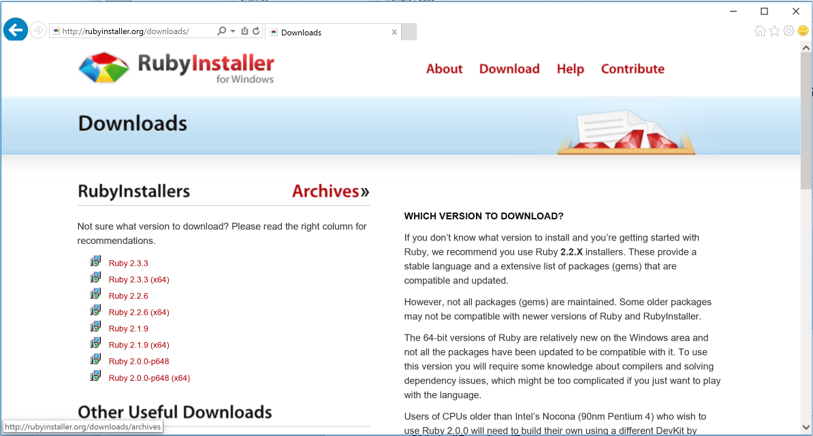

Select “Ruby 2.3.3 (x64)” and run the installer.

Select “OK” for English language.

Accept License Agreement.

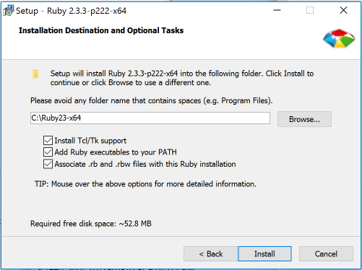

Check all of the boxes and click “Install.”

Add ruby to path.

Set PATH=%PATH%;C:\Ruby23-x64\bin

Create desktop folder for running process: iModules-Converge Reports

Paste “imod_report.rb” into folder.

Create shortcut for “C:\Windows\System32\cmd.exe /k ruby imod_report.rb”

Edit shortcut properties.

Start in: “C:\Users\chriseady\Desktop\iModules Reports” (the path to your folder)